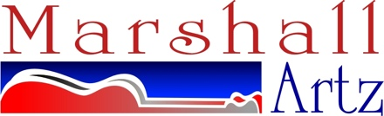
bandmail@marshallartz.net
http://www.marshallartz.net

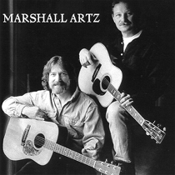

Marshall Artz is a guitar duo performing a distinctive original blend of Americana, Indie Folk and Blues forged together in a powerful acoustic style. With five albums released internationally the duo features the combined talents of Brad Marshall on lead, rhythm, and slide guitar and Kevin Artz on rhythm and fingerstyle guitar, vocals and harmonica. Brad’s background in rock and blues meets with Kevin’s background in folk, folk-rock and bluegrass to create an original and dynamic acoustic sound. Their performances blend two guitars into a rhythmic and melodic mix that suggests a full band rather than just two guitars.
Marshall Artz having played over 1500 shows are performing at top venues, clubs, fairs, colleges and universities in the Mid-Atlantic region of the US. They have been guests on live radio programs and featured in live performances for American University’s WAMU as well as the World Folk Music Association showcases at the Birchmere in Alexandria, Virginia. They performed as opening act for national artists Tracy Chapman and Dave Mason at venues including the Ram’s Head Tavern in Annapolis, Maryland, The Birchmere, The National Theater (Richmond), Ting Pavilion and many more.

The entire Marshall Artz collection consisting of 5 all original music CDs are available for downloads from Apple iTunes, Amazon.com, Spotify or check out any of your favorite download sources for acoustic guitar music at its best. Also available for purchase or downloads from the Marshall Artz website. www.marshallartz.net

Kevin Artz – Rhythm Guitar, Finger style Guitar, Harmonica, Lead Vocal
Brad Marshall – Lead Guitar, Slide Guitar, Bass Guitar, Harmony Vocal

